Spatial Futures

Introduction
The need for – and the opportunity to introduce – a national spatial framework for England has never been greater.
There are a wide range of reasons for this but this short note focusses on just two of them. These are that, first, the current Government is undertaking initiatives that can only be improved by having a clearly expressed and mapped spatial basis and, second, that there exists an implicit spatial strategy already.

Current Government initiatives
The Government is currently engaged in at least three initiatives the value and impact of which will be significantly lessened if there are not set within the context of a clear understanding of the spatiality of their work.
In addition, from the bottom up, important work on defining spatial policy on a larger than local basis is being done at city region level. Others on the group are, however, better informed on these initiatives than I.

Industrial Strategy
In July, the new Prime Minister, Theresa May, established a new Department, Business, Energy and Industrial Strategy, one of the tasks of which is to prepare an industrial strategy.
Being optimistic, it appears that the need for this strategy to have a degree of spatial specificity has already been recognised. Greg Clark, Secretary of State for Business, Energy and Industrial Strategy has stated that:
In my view any successful industrial strategy has to be local. Governments are fond of quoting national figures – of economic growth, of productivity, of employment. But the truth is economic growth does not exist in the abstract. It happens in particular places when a business like yours is set up, or takes on more people, or expands its production. And the places in which you do business are a big part of determining how well you can do.
And they’re very different places. It’s obvious that South Kensington here has very different needs from Middlesbrough. Yet for too long, government policy has treated every place as if they were identical. It seems to me that helping Cornwall make the best of its future is as vital to a comprehensive national success as helping Birmingham – but what is needed in each place is different, and our strategy must reflect that.
If this does indeed show an awareness of the need for spatial differentiation, then there is the need to lobby Government swiftly on this point.

National Infrastructure Commission
The National Infrastructure Commission was established to look at the UK’s future needs for nationally significant infrastructure. As well as producing a number of reports already, the Commission is currently preparing its first National Infrastructure Assessment and, also, very relevantly, undertaking a study to maximise the potential of the Cambridge – Milton Keynes – Oxford Corridor.
The need to relate all the work of the Commission very clearly to a national spatial view is clear.

National Infrastructure - HS2 and London Airport Capacity
The Government is currently engaged in decision making processes in relation to the two most significant items of infrastructure that the country has dealt with for decades – HS2 and increasing capacity at London’s airports.
It is obvious that decisions on both of these must be related to their local spatial impact but there is an equal need to take these decisions within a clear understanding of the impacts that these will have on a much wider view of the spatial distribution of economic growth, environmental quality and housing. It is hard to see how this can be done adequately without a national spatial framework.

An implicit spatial strategy

Existing spatial designations
Whilst the main planning policy document for England, the NPPF, is aspatial (even though it impacts differentially on different areas) a wide range of current Government policies, initiatives and designations are specifically tied to particular spatial areas.
This may best be illustrated simply by listing some of those which have spatial boundaries and which are already available in map form. This list is only the tip of an iceberg:
- Flood risk areas (http://maps.environment-agency.gov.uk/wiyby/wiybyController?topic=fwa&layerGroups=default&lang=_e&ep=map&scale=2&x=534555.9375&y=179542.08333333334#x=572987&y=209175&lg=1,&scale=2)
- Green Belts (http://www.cpre.org.uk/what-we-do/housing-and-planning/green-belts )
- Housing Zones (https://www.google.com/maps/d/viewer?mid=1vrNX4wJw5bBiMRzFUpv54KsaKWA&ll=52.88902459716784%2C-1.4105600999999979&z=7)
- Local Enterprise Partnerships and Enterprise Zones (https://www.gov.uk/government/uploads/system/uploads/attachment_data/file/229400/121115_Enterprise_Zones_map.pdf )
- Natura 2000 sites (http://www.eea.europa.eu/data-and-maps/figures/distribution-of-natura-2000-sites-across-eu-member-states-1 )
- Trans European Networks (http://ec.europa.eu/transport/infrastructure/tentec/tentec-portal/site/maps_upload/corridors_png/C8_northsea_med.pdf )
- Water stress areas (https://www.theguardian.com/graphic/0,,2002043,00.html)
The final page of this note contains some of these maps. One key – and potentially straightforward – purpose of a national spatial framework would be to put such maps together both to gain a greater understanding of the interrelationships and of the conflicts.

Spatially differentiated policy
There are some cases where Government policy is not readily transferrable to a map base but which has an identifiable differential effect on different parts of the country. One of the clearest examples of this is the difference in Government spending per head by region. The diagram below shows this over time but this can also be shown for relevant elements of spending such as transport, housing or environmental services.

This analysis could equally be applied to spending on higher education and many other spending heads.

Conclusion
This note just scratches the surface of the myriad reasons why a national spatial framework is needed and the benefits that would accrue from having one.
Kelvin MacDonald 11 November 2016
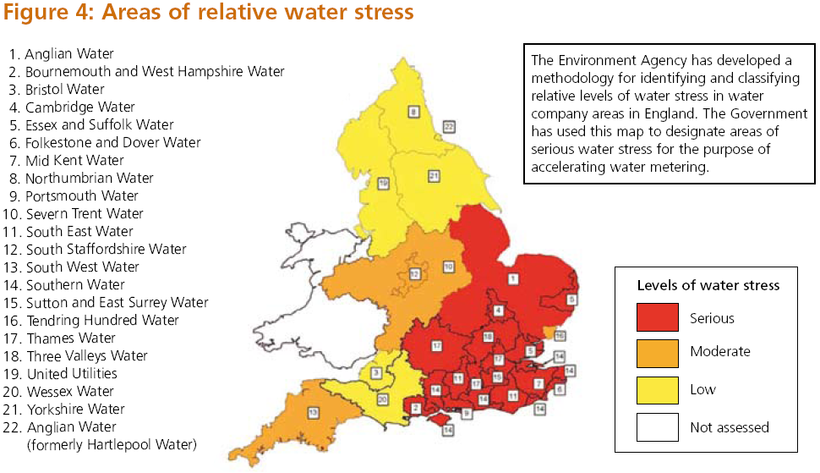
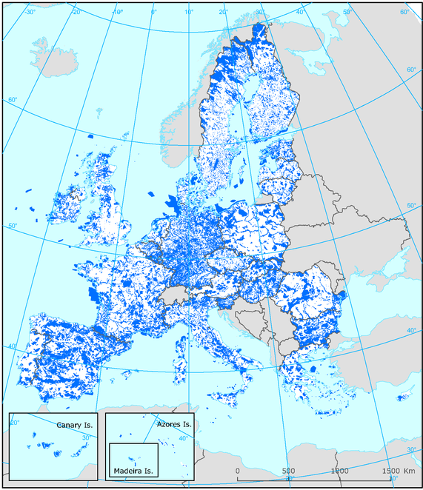

This note only deals with England. The case for a UK-wide spatial framework is even more evident and pressing but a) Scotland, Wales and Northern Ireland already have spatial strategies and b) the English element of a UK spatial framework is a necessary first step.
https://www.gov.uk/government/speeches/the-importance-of-industrial-strategy
https://www.gov.uk/government/organisations/national-infrastructure-commission
https://www.gov.uk/government/organisations/high-speed-two-limited
https://www.gov.uk/government/news/government-decides-on-new-runway-at-heathrow
The House of Commons CLG Select Committee held an inquiry into the NPPF and its report (http://www.publications.parliament.uk/pa/cm201012/cmselect/cmcomloc/1526/1526.pdf) found in relation to a spatial element to the NPPF that: There is evidence of concern that the draft NPPF is largely "placeless". While we recognise that it was never the intention of the Government to issue the draft NPPF as a ‘spatial’ plan, we consider that its impact and effectiveness would be improved if the possibility of differential impacts of its policies on different parts of the country were to be recognised in the Framework and that, where a local authority seeks to recognise local variations, the NPPF encourages local authorities to ensure that there is a robust evidence base in place to justify these variations, and thus, that it serves the Government’s stated intention to re-balance the national economy. (para. 47.)
This does raise the whole question about the relationship between ‘Brexit’ and the increased need for a national spatial framework that this gives rise to – but again, others are better qualified than I on this.

